Electrical circuits: Teacher background information
A simple circuit is an electrical circuit consisting of a power source, two wires and a load.
The components of a simple circuit:
- Load — a device or component that slows down the flow of electricity and transforms electrical energy into other forms of energy, e.g. electrical appliances, lights.
- Power source — provides energy and electricity to the electrical circuit. A cell or a series of cells (battery) could be used as a power source.
- Wire — allows electricity to flow around the circuit and transfers electrical energy from one component to another.
The circuit is complete when all the components are joined and allow electricity to flow right around the circuit.
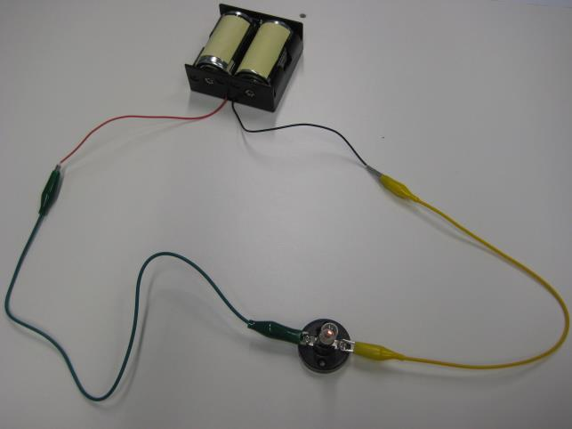
Power source
Wires
Load
It is important that students do not develop the misconception that electricity and electrical energy are the same thing. They flow in completely different ways in a circuit and are measured using different units. The flow of electricity is associated with the movement of charged matter, whereas the flow of electrical energy is associated with electromagnetic waves. The flow of electricity is measured in amperes (coulombs per second), while the flow of electrical energy is measured in watts (joules per second). These concepts are dealt with in Years 9 and 10.
In Year 6, students should be made aware that electricity and electrical energy are not synonymous. While the same amount of electricity flows continuously around the circuit, electrical energy is transformed into other forms of energy (i.e. movement, light and heat) that are no longer available for use within the circuit. Each time a transformation occurs, less electrical energy is available for use in subsequent components. This can be observed in a series circuit with multiple light bulbs — each subsequent light bulb is progressively dimmer, because less electrical energy is available for transformation into light energy.

